**IT2120 - Probability and Statistics**

**Lab Sheet 045**

**IT24102799**

**Siriwardhana S.A.D.N**

Exercise

1. Import the dataset (’Exercise– Lab 05.txt’) into R and store it in a data frame called ”Delivery Times”

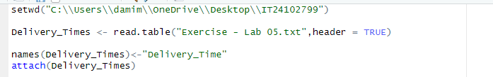

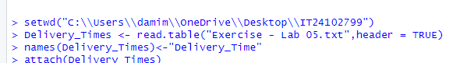

2. Draw a histogram for deliver times using nine class intervals where the lower limit is 20 and upper limit is 70. Use right open intervals.

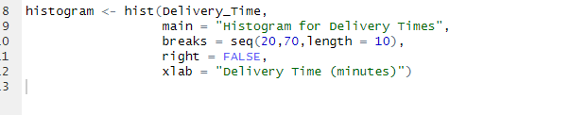

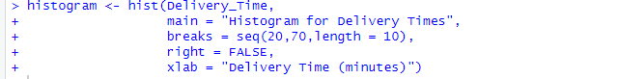

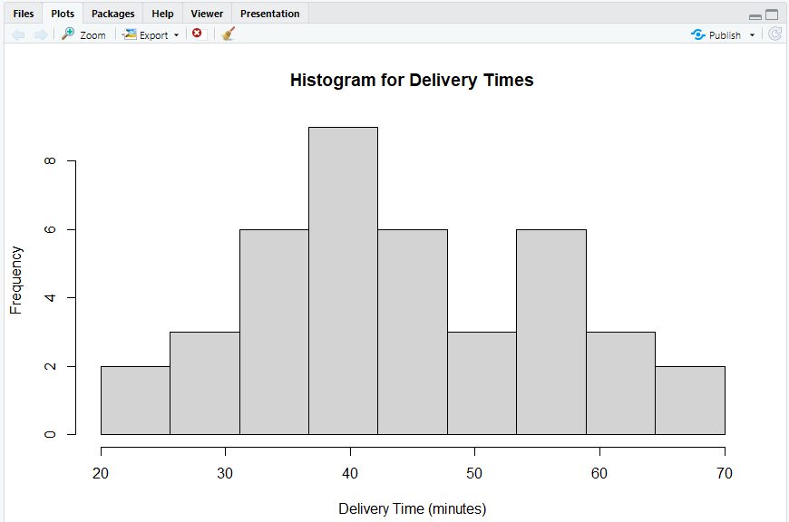

4. Draw a cumulative frequency polygon (ogive) for the data in a separate plot.

